User Manual

*Oct 16*

*Version 1.00*

*Northwest Missouri State University*

*Graduate Directed Project – I*

*Crazy Coders*

Document Revisions

|  |  |  |
| --- | --- | --- |
| Date | Version Number | Document Changes |
| 06/10/2016 | 1.00 | Initial Draft |
|  |  |  |
|  |  |  |
|  |  |  |

Table of Contents

1. Introduction
   1. Scope and Purpose
   2. Process Overview
2. Process/Workflow
   1. Procedure 1
   2. Procedure 2
3. Introduction
   1. Scope and Purpose

The purpose of the application is to give a campus tour of Northwest Missouri State University. The audience will be the freshman students who joined the university and who want to get familiar with the infrastructure and the facilities provided at different locations in the university.

* 1. Process Overview

On launching the Campus Cruize app the user will directly land into the application home screen.

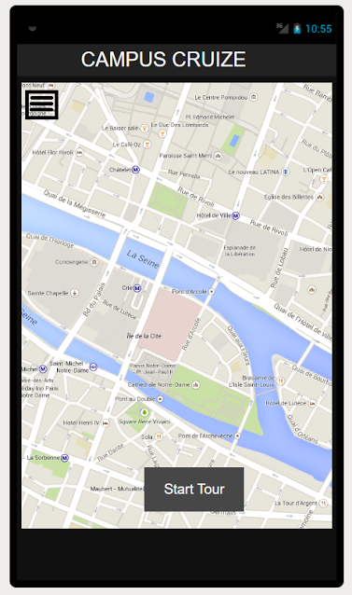

The home screen will consist a dynamic map showing the user his current location. There will be a button to start the campus tour. On clicking the button, the user will be directed on a campus tour where he would first be taken to a nearest building. The tour starts from the building and continues till all the buildings on the route map are traversed.

